भारतमौसमविज्ञानविभाग |  | India Meteorological Department
Thursday,19th June 2025 (29 Jyeshtha 1947 Saka)
Summary of observations recorded at 0830 hours IST: Southwest monsoon further advanced over most parts of Bihar and some more parts of east Uttar Pradesh today, on 19th June 2025. The Northern Limit of Monsoon now passes through 25.0°N/60.0°E, 25.0°N/65.0°E, 25.5°N/70.0°E, Barmer, Jodhpur, Jaipur, Gwalior, Khajuraho, Sonbhadra, Ballia, 28.0°N/83.5°E and 30.5°N/81.5°E. Conditions are favourable for further advance of Southwest monsoon over remaining parts of North Arabian Sea, some more parts of Rajasthan, remaining parts of Madhya Pradesh, some more parts of Uttar Pradesh, some parts of Uttarakhand, Himachal Pradesh, Jammu-Kashmir-Ladakh-Gilgit-Baltistan-Muzaffarabad during next 2-3 days. Conditions are also becoming favorable for further advance of southwest monsoon over some parts of Punjab & Haryana during subsequent 2-3 days. The Well Marked Low Pressure Area over Gangetic West Bengal & neighbourhood lay over northeast Jharkhand & adjoining Gangetic West Bengal at 0530 hrs IST of today. It persisted over the same region at 0830 hrs IST of today, the 19th June 2025. The associated upper air cyclonic circulation extended upto 7.6 km above m. s. l. tilting southwards with height. It is likely to move slowly northwestwards during next 24 hours. The Low-Pressure Area over central parts of Rajasthan & neighbourhood became less marked at 0530 hrs IST of today. However, the associated upper air cyclonic circulation lay over southwest Rajasthan. It persisted over the same region and extended upto 1.5 km above m. s. l. The cyclonic circulation lay over northeast Rajasthan & neighbourhood at 0530 hrs IST of today. It then persisted over the same region and extended upto 4.5 km above m. s. l. The trough from Punjab to north Gujarat region ran from northwest Uttar Pradesh to northeast Gujarat region at 0530 hrs IST of today. It then ran from northwest Uttar Pradesh to north Gujarat Region across the cyclonic circulation over northeast Rajasthan & neighbourhood between 3.1 & 5.8 km above m. s. l. An east-west trough ran from south Punjab to south Assam across the cyclonic circulation over northeast Rajasthan, north Madhya Pradesh and the cyclonic circulation associated with the Well-Marked Low-Pressure Area over Jharkhand & adjoining Gangetic West Bengal at 0.9 km above m. s. l. An off-shore trough at sea level chart ran from north Konkan coast to north Kerala coast. The Western Disturbance as cyclonic circulation over Punjab & neighbourhood lay as a trough in middle tropospheric westerlies with its axis at 5.8 km above m. s. l. roughly along Long. 76°E to the north of Lat. 30°N at 0530 hrs IST of today. It moved away northeastwards. The upper air cyclonic circulation over central parts of Uttar Pradesh & neighbourhood became less marked.
Day temperatures were markedly above normal (> 5.1°C) at isolated places over Himachal Pradesh. appreciably above normal (3.1°C to 5.0°C) at most places over Arunachal Pradesh; at few places over Assam & Meghalaya and Jammu-Kashmir-Ladakh-Gilgit-Baltistan-Muzaffarabad; at isolated places over Odisha, coastal Andhra Pradesh & Yanam and Tamil Nadu, Puducherry & Karaikal; above normal (1.6°C to 3.0°C) at few places over Nagaland, Manipur, Mizoram & Tripura, west Rajasthan and coastal Karnataka; at isolated places over west Uttar Pradesh, Konkan & Goa, Vidarbha, Telangana and Rayalaseema. near normal (-1.5°C to 1.5°C) at many places over east Madhya Pradesh, Marathwada and Kerala & Mahe; at most places over Andaman & Nicobar Islands, sub Himalayan West Bengal & Sikkim, Uttarakhand, north interior Karnataka, south interior Karnataka and Lakshadweep; at few places over Bihar, east Uttar Pradesh, Punjab, west Madhya Pradesh and Madhya Maharashtra; at isolated places over Haryana-Chandigarh-Delhi, Saurashtra & Kutch and Chhattisgarh. The highest maximum temperature of 43.1°C was reported at Jaisalmer (Rajasthan).
The Southwest Monsoon has been vigorous over Jharkhand, Gujarat Region and active over Sub-Himalayan West Bengal & Sikkim, Gangetic West Bengal, Bihar, Konkan & Goa and Madhya Maharashtra. It has been subdued over Marathwada, coastal Andhra Pradesh, Telangana and south interior Karnataka.
Total 333 stations reported rainfall today. Total rainfall is 488.2 cm. Total 320 stations reported rainfall today whose normals are available. Total rainfall is 439.7 cm with normal station total is 242.5 cm.
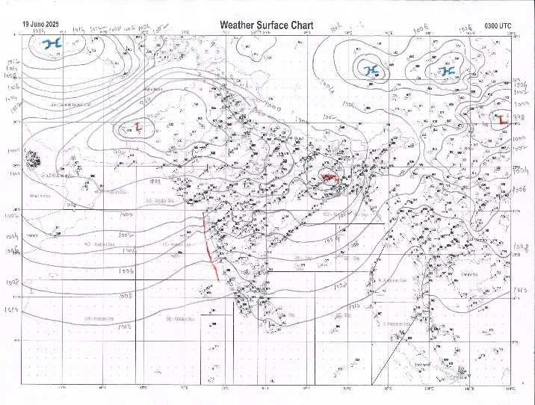 | 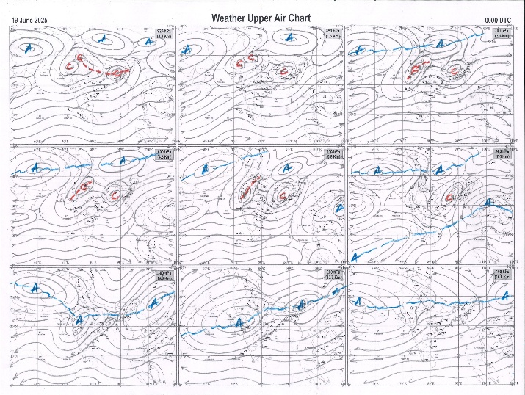
g.1. Analysed surface chart based on 03z observation | Fig.2. Analysed upper air chart based on 00z observation

Dr. S.D.Sanap
Scientist ‘D’
CR & S Office, Pune  Issued at 1245 hrs. IST |  | Weather Forecasting Division  CR&S, Pune

Indian regions | Realised rainfall (chief amount in cm during past 24 hrs):
East | most places: Nagaland-Manipur-Mizoram-Tripura+++, Sub-Himalayan West Bengal & Sikkim+++, Gangetic West Bengal# and Jharkhand#  many places: Arunachal Pradesh, Assam & Meghalaya#, Odisha+++ and Bihar+++  Mawsynram 31.4, Bau kanke 30.0, Nimdih 29.0, Jamshedpur 25.9, Kharidwar 21.3, Cherrapunji (rkm) 20.0, Mawkyrwat 19.7, Bankura (CWC) 19.2, Tiring 17.9, Lava 15.6, Bahalda 15.2, Belonia 15.0, Purulia 14.3, Imamganj 13.0, Bagafa 12.1, Kauwakol 12.0, Hilla t.e. 11.5, Kalimpong 10.0, Gaya AP 8.7, Tuting & Tuting AWS 4.9 each, Titlagarh 4.5, Bomdila 2.7, Aizwal 1.4.
North | a few places: west Uttar Pradesh+++, Uttarakhand and east Rajasthan+  isolated places: east Uttar Pradesh, Haryana, Punjab, Himachal Pradesh, Jammu-Kashmir and Ladakh and west Rajasthan  Shikohabad 12.0, Jalesar 10.2, Bharatpur tehsil SR 8.5, Meerut 5.8, Deeg SR 5.7, Chhibramau & Tatgarh SR 5.5 each, Madhopur 4.4, Roorkee 4.2, Julana 3.8, Raipur SR 3.6, Ayoadhya 3.5, Haldwani 3.2, Nainital & Sumerpur SR 2.8 each, Ayodhya (ag) & Khanna 2.6 each, Sonepat 2.5, Samba AWS 2.4, Burmal ARG 1.8, Rohtak 1.6, Pathankot IAF 1.4, Erinpura / Jawai dam 0.9, Pachhad & Badarwah 0.7 each, Sundarnagar 0.6, Dharmsala 0.4.
Central | a few places: west Madhya Pradesh+ and Chhattisgarh+++  isolated places: east Madhya Pradesh and Vidarbha  Kusmi 20.1, Kathiwada 10.5, Porsa 8.3, Sanna 7.9, Alirajpur 6.6, Jashpurnagar 6.1, Kuhi 1.5, Venkatnagar 1.3, Majhauli 0.8, Umaria-aws & Bhadravati 0.5 each, Nagpur aerodrome 0.1.
Peninsula | most places: Gujarat Region#, Konkan & Goa#, coastal Karnataka and Kerala+  many places: Madhya Maharashtra+++  isolated places: Saurashtra & Kutch+, Marathwada, coastal Andhra Pradesh◆, Telangana, Rayalaseema◆, Tamil Nadu+ and interior Karnataka  Matheran 26.2, Kaprada 25.9, Dangs (ahwa) 25.8, Wada 21.7, Khalapur 20.5, Lonavala ARG 19.9, Mahabaleshwar 19.0, Igatpuri 16.5, Sutrapada 9.7, Ponnani 7.3, Abad city 7.0, Kodinar 6.9, Veraval & Chinnakalar 6.8 each, Chalakudi 6.6, G bazar 6.5, Uppinangadi 6.4, Vellanikkara 5.7, Valparai PTO 4.8, Gersoppa 4.6, Agumbe emo 4.3, Londa 3.9, Kammardi & Kottigehara 3.5 each, Shirali PTO 3.2, Khanapur 2.3, Khultabad 1.2, Chinna chinta kunt 0.9, Phulambri, Veepangandla & Haveri PTO 0.7 each, Madanapalle 0.2, Sambhajinagarobsy, Paderu & Prattipadu (ARG) 0.1 each.
Islands | many places: Andaman & Nicobar+ and Lakshadweep  Port blair 8.0, Maya bandar 1.0, Long island 0.9, Minicoy 0.8, Amini 0.3, Agathi 0.2.
Table 2. Forecast / warnings (distribution of rain / thundershowers) for 7 days (valid from time of origin upto 0830 hrs IST of next day)
Sr N. |  | Sub-division Name | Day 1 | Day 2 | Day 3 | Day 4 | Day 5 | Day 6 | Day 7 | Sr. No. | Sub-division Name | Day 1 | Day 2 | Day 3 | Day 4 | Day 5 | Day 6 | Day 7
 |  |  | 19 Jun | 20 Jun | 21 Jun | 22 Jun | 23 Jun | 24 Jun | 25 Jun |  |  | 19 Jun | 20 Jun | 21 Jun | 22 Jun | 23 Jun | 24 Jun | 25 Jun
 | 1 | Andaman Nicobar Islands | F  | W  | W | W | W | F | F | 19 | west Madhya Pradesh | W +  | F +  | F  | F +  | F +  | F ++ | W ++
 | 2 | Arunachal Pradesh | W ++  | F +  | F +  | W++ | W++ | F + | F + | 20 | east Madhya Pradesh | F +  | W +  | W ++  | W +  | W +  | W ++ | W ++
 | 3 | Assam-Meghalaya | W++ | W+ | W +  | W++ | W++ | W ++ | W + | 21 | Gujarat region | W #  | F +  | W +  | W ++  | W ++  | F + | F +
 | 4 | Nagaland-Manipur-Mizoram-Tripura | W++ | W++ | W +  | W++ | W + | W ++ | W + | 22 | Saurashtra and Kutch | W + | F  | F  | W+ | F+ | F + | F +
 | 5 | Sub Himalayan West Bengal/Sikkim | W++ | F | F | W + | W ++ | W + | F | 23 | Konkan and Goa | W #  | W + | W + | W + | W + | W | W
 | 6 | Gangetic West Bengal | W++ | F | S | W+ | F | F | W + | 24 | Madhya Maharashtra | F #  | S ++ | I + | I + | I + | I + | I +
 | 7 | Odisha | W ++  | F + | F + | F + | S | F | F | 25 | Marathwada | I  | I  | I | I | I | I | I
 | 8 | Jharkhand | W# | W++ | F +  | F  | F  | F + | W + | 26 | Vidarbha | F  | F  | F  | S  | I  | I | S
 | 9 | Bihar | F++ | S+ | F+ | F++ | F++ | S | S | 27 | Chhattisgarh | F ++  | F ++  | F +  | S  | S  | S | F
 | 10 | east Uttar Pradesh | F+ | F++ | W++ | W+ | F +  | F +  | F +  | 28 | Coastal Andhra Pradesh and Yanam | I  + | I + | I+ | I  | I  | I | I
 | 11 | west Uttar Pradesh | F++ | F+ | W+ | W+ | W +  | F +  | W +  | 29 | Telangana | S  | S  | I  | I  | I  | I | I
 | 12 | Uttarakhand | F+ | F+ | F+ | W++ | F+ | F+ | F+ | 30 | Rayalaseema | I + | I + | I + | I | I | I | I
 | 13 | Haryana,Chandigarh and Delhi | I  | F+  | W + | W + | W + | S | W + | 31 | Tamil Nadu, Puducherry and Karaikal | I  + | I  + | I + | I | I | I | I
 | 14 | Punjab | I  | S  | F + | W + | F + | S | W + | 32 | Coastal Karnataka | W +  | W | W + | W + | W + | W + | W +
 | 15 | Himachal Pradesh | S | F | F + | W ++ | F + | F + | W ++ | 33 | North interior Karnataka | S | S | S | I | I | I | I
 | 16 | Jammu-Kashmir and Ladakh | I | I | S  | W+ | F  | F  | S+ | 34 | South interior Karnataka | S | I | I | I | I | I | I
 | 17 | west Rajasthan | I  | I  | I  | I  | S  | S  | I  | 35 | Kerala and Mahe | W +  | F | F | W + | W + | W + | W +
 | 18 | east Rajasthan | F++ | S + | S  | F+ | F++ | F+ | S  | 36 | Lakshadweep | W  | F | F | W | W | W | W
Legends: D = Dry I = Isolated S = Scattered F = Fairly widespread W = Widespread #= heavy to very heavy rain at a few places with extremely heavy rain at isolated places +++= heavy rain at a few places with very heavy rain at Isolated places ++= heavy to very heavy rainfall @=Isolated exceptionally heavy rainfall + = heavy rain ●/*= rain or snow ♦ = very light rain ≡=fog= thunderstorm with lightning =Squall / Gusty / gale / strong wind ­ =cold wave/cold day += heat wave/warm night/hot and humid weathe r=Duststorm =ground frost = Hail
Fig. 4: Districtwise warnings for five days for Maharashtra State
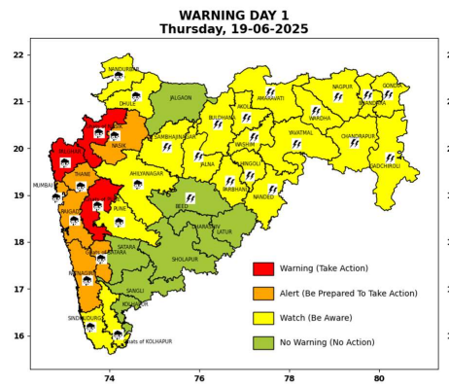 | 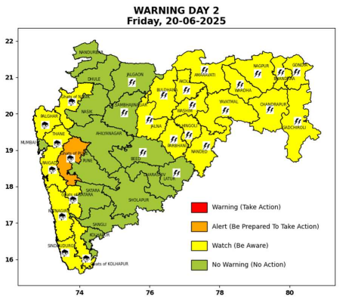 | 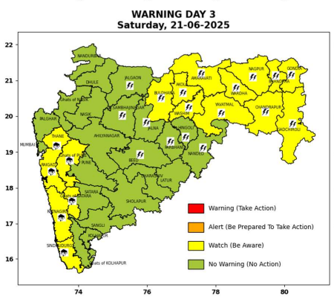 | 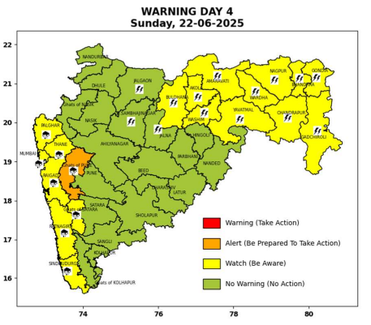 | 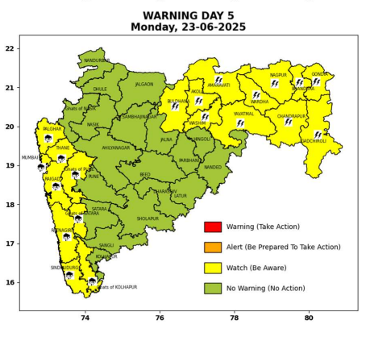

Pune, Lohegaon and Pashan observations at 0830 hrs. IST of Today
 | Temperature (°C) |  |  |  |  | Humidity (%) |  |  |  | Rainfall (mm)
 | Max.  past  24 hrs | Dep.  from  normal | Min.  past  24 hrs. | Dep.  from  normal | Dry  Bulb | At 0830 hrs. IST | Dep.  From  normal | At 1730  hrs. IST of y’day | Dep.  from  normal | Past  24 hrs. | Since  1st June | Dep.  from  normal
PNE | 29.0 | -1.9 | 23.1 | 0.2 | 23.6 | 96 | 17 | 92 | 22 | 31.3 | 210.2 | 113.9
PSN | 27.8 | - | 21.9 | - | 23.2 | 100 | - | 92 | - | 32.9 | 229.9 | -
LHG | 30.2 | -1.8 | 24.5 | 3.5 | 24.8 | 93 | 17 | 86 | 24 | 29.6 | 203.8 | 144.2

 |  |  |  |  |  |  | Local (Pune and neighbourhood) forecast
Max./Min. Temperature (°C) |  |  |  |  |  |  |  |  | Weather
Date | Pune | Pashan | Lohegaon | Chinchwad | Lavale | Magarpatta | NDA | Koregoan Park
19/06/25 | 26 / 23.1* | 26 / 21.9* | 27 / 24.5* | 26 / 23.0* | 25 / 22.5* | 26 / 24.0* | 25 / 22.6* | 26 / 24.2* | Overcast, moderate to heavy rain very likely, (Very heavy to extremely heavy rainfall at isolated places in ghat areas).
20/06/25 | 28 / 22 | 28 / 21 | 29 / 24 | 28 / 23 | 27 / 22 | 28 / 23 | 27 / 22 | 28 / 24 | Generally cloudy sky. Light to moderate rain very likely. (Heavy to very heavy rainfall at isolated places in ghat areas).
21/06/25 | 29 / 22 | 29 / 21 | 30 / 24 | 29 / 23 | 28 / 22 | 29 / 23 | 28 / 22 | 29 / 25 | Generally cloudy sky. Light to moderate rain very likely.
22/06/25 | 30 / 23 | 30 / 22 | 31 / 25 | 30 / 24 | 29 / 23 | 30 / 24 | 29 / 23 | 30 / 26 | Generally cloudy sky. Light rain very likely.
23/06/25 | 30 / 23 | 30 / 22 | 31 / 25 | 30 / 24 | 29 / 23 | 30 / 24 | 29 / 23 | 30 / 26 | Generally cloudy sky. Light rain very likely.
24/06/25 | 29 / 22 | 29 / 21 | 30 / 24 | 29 / 23 | 28 / 22 | 29 / 23 | 28 / 22 | 29 / 27 | Generally cloudy sky. Light rain likely.
25/06/25 | 29 / 22 | 29 / 21 | 30 / 24 | 29 / 23 | 28 / 22 | 29 / 23 | 28 / 22 | 29 / 27 | Generally cloudy sky. Light rain likely.
Rainfall Distribution |  |  | Rainfall Categories | Rainfall (mm) |  | Cloud condition |  |  |  | Rainfall Intensity |  | Range
Widespread (W) | 76-100% |  | Very Light rain | Trace to 2.4 mm |  | Mainly clear sky |  | 1-2 oktas |  | Light Spell |  | 1 cm/hr
 |  |  | Light rain | 2.5 to 15.5 mm |  | Partly cloudy sky |  | 3-4 oktas |  | Moderate Spell |  | 1-2 cm/hr
Fairly Widespread (FW) | 51 – 75% |  | Moderate rain | 15.6 to 64.4 mm |  | Generally cloudy sky |  | 5-7 oktas |  | Intense Spell |  | 2-3 cm/hr
Scattered (S) | 26 – 50% |  | Heavy rain | 64.5 to 115.5 mm |  | Overcast |  | 8 oktas |  | Very Intense Spell |  | 3-5 cm/hr
isolated (I) | 1 – 25% |  | Very heavy rain | 115.6 to 204.4 mm |  |  |  |  |  | Extremely Intense Spell |  | 5-10 cm/hr
D (D) | No Rain |  | Extremely heavy rain | ≥ 204.5 mm |  |  |  |  |  | Cloudburst |  | > 10 cm/hr
Probability Terms in %: |  |  | Heavy snow | 6.5 to 11.5 cms water equivalent of rain
unlikely | < 25 |  | Very heavy snow | 11.6 to 20.4 cms water equivalent of rain
likely | between 25 50
very likely | between 51 75
most likely | >75
* = realized temperature
Mumbai (Colaba) |  |  |  | Nagpur (AP)
Date 2025 | T max °C | T min °C | Weather | T max °C | T min °C | Weather
19/06 | 29 | 25 | Generally cloudy sky with Heavy rainfall. | 37 | 26 | Thunderstorm accompanied with lightning and rain.
20/06 | 30 | 25 | Generally cloudy sky with moderate rain. | 35 | 26 | Generally cloudy sky with a few spells of rain or thundershowers accompanied with Lightning.
21/06 | 31 | 25 | Generally cloudy sky with intermittent heavy rainfall. | 34 | 26 | Generally cloudy sky with a few spells of rain or thundershowers accompanied with Lightning.
22/06 | 31 | 26 | Generally cloudy sky with intermittent heavy rainfall. | 34 | 26 | Generally cloudy sky with a few spells of rain or thundershowers accompanied with Lightning.
23/06 | 32 | 26 | Rain. | 35 | 26 | Generally cloudy sky with a few spells of rain or thundershowers accompanied with Lightning.
24/06 | 32 | 26 | Rain. | 34 | 26 | Generally cloudy sky with a few spells of rain or thunderstorm.
25/06 | 31 | 26 | Rain. | 34 | 26 | Generally cloudy sky with a few spells of rain or thunderstorm.

